1 - Optimal combination forecasts for hierarchical time series (Rob J Hyndman, Roman A Ahmed)

Define Bottom-up and top-down methods and proposed Optimal Combination.
The authors propose a new method that forecasts all series at all levels independently and then combines them using a regression model.
Results:
In a study of 600 simulated hierarchical time series, the optimal combination method performed well across all levels. While "Top-down" was best at the very top and "Bottom-up" best at the very bottom, the new method was consistently accurate across the entire hierarchy and outperformed both conventional methods in total Mean Absolute Error (MAE).

2 - Optimal forecast reconciliation for hierarchical and grouped time series through trace minimization (Shanika L Wickramasuriya, George Athanasopoulos and Rob J Hyndman)
Say that the method of Hyndman 2011 is impossible because of covarince matrix of coherency error is non-identifiable

Proposed solution: MinT
Instead of minimizing "coherency errors," MinT minimizes the Mean Squared Error (MSE) of the reconciled forecasts across the entire hierarchy.

Key Advantage: Unlike "Bottom-Up" (which ignores relationships) or "Top-Down" (which is biased), MinT uses information about the correlation structure between all series in the hierarchy.

Scalability: The authors derive a computationally efficient representation of the solution that avoids inverting massive matrices, making it scalable for large hierarchies.
MinT(Shrink)
You cannot use the standard MinT(Standard) approach for massive hierarchies (like the 2,047 series) because the matrix calculations fail.
MinT(Shrink) overcomes this limitation by using a shrinkage estimator for the covariance matrix,

4 - Hierarchical time series forecasting via Support Vector Regression in the European Travel Retail Industry (Juan Pablo Karmy, Sebastián Maldonado)
three hierarchical time series approaches (BU, TD, Middle-out) based on Support Vector Regression and compared it with Arima and Holt-winter. Without reconciliation.
Benchmark Datasets: Four standard datasets used in previous literature ("htseg2", "Austourism", "Departures", and "Melsyd").
Case Study (Travel Retail): Sales data provided by Generation Research AB regarding the European beauty market from 2013 to 2016 contain 20,802 products from 82 companies.

5 - Model selection in reconciling hierarchical time series (Mahdi Abolghasemi · Rob J. Hyndman · Evangelos Spiliotis3 · Christoph Bergmeir)
Introduce Conditional Hierarchical Forecasting (CHF), and compare it with traditional (BU, TD, Combination Optimal Forecasting (COM))
CHF algorithm flowchart
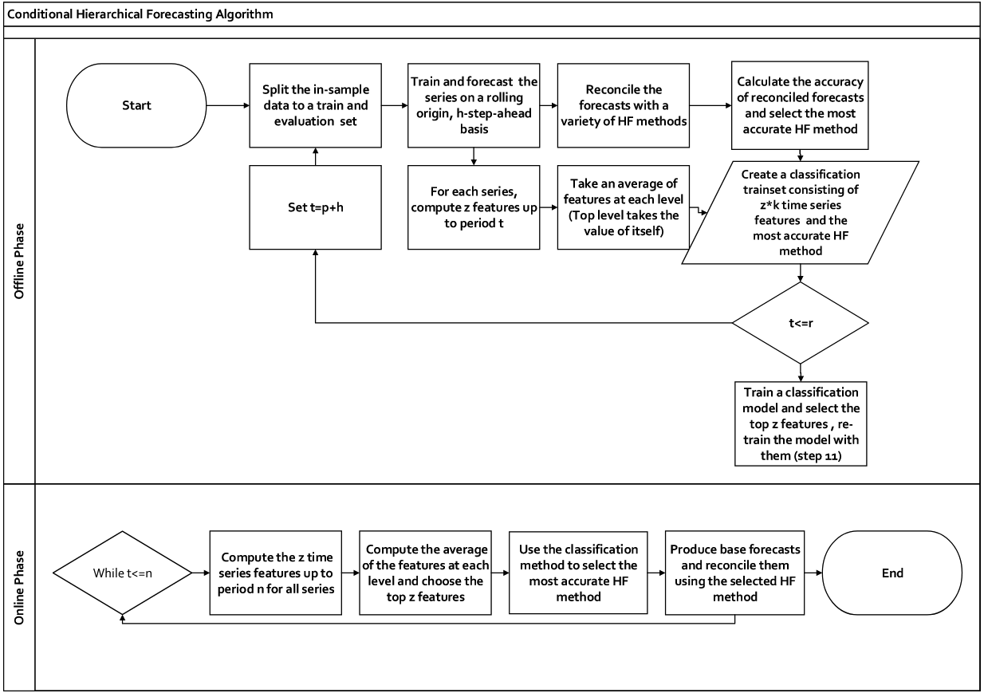

Explaination:
The process is divided into two distinct phases: the Offline Phase (Training) and the Online Phase (Forecasting).

1. Offline Phase (The Training Loop)
The goal of this phase is to train a machine learning model (classifier) to recognize which hierarchical forecasting (HF) method works best given specific data characteristics.
- Data Splitting & Rolling Origin: The process starts by splitting the historical data into a training set and an evaluation set. It uses a "rolling origin" approach, meaning it iteratively moves forward in time, adding new data points to simulate real-world forecasting scenarios .
- Parallel Paths: Inside the loop, two parallel processes occur:
  - Performance Evaluation (The "Label"):
    - The system generates base forecasts and then reconciles them using various standard methods (like Bottom-Up, Top-Down, or Minimum Trace) .
    - It calculates the accuracy for each method and identifies the "winner" (the most accurate method) for that specific time window. This "winner" becomes the target label for the machine learning model .
  - Feature Extraction (The "Input"):
    - Simultaneously, the algorithm calculates statistical time series features (z features) for every series in the hierarchy up to the current time period ($t$) . These features include metrics like trend strength, entropy, or seasonality .
    - It averages these features at each hierarchical level to create a summary of the data's behavior .
- Training the Classifier:
  - The features (inputs) and the most accurate HF method (labels) are combined into a classification training set .
  - A classification model (such as XGBoost) is trained to learn the relationship between the time series features and the best performing reconciliation method .

2. Online Phase (The Application Loop)
This phase applies the trained model to generate forecasts for new, future data.
- Feature Computation: As new data comes in ($t <= n$), the algorithm computes the same time series features used in the offline phase .
- Feature Aggregation: It calculates the average of these features for each hierarchical level .
- Selection (Prediction): The trained classification model analyzes these features and predicts/selects which HF method is most likely to be the most accurate for the current data .
- Final Forecasting: The system produces base forecasts and reconciles them using only the specific HF method selected by the classifier .

Rolling avg :
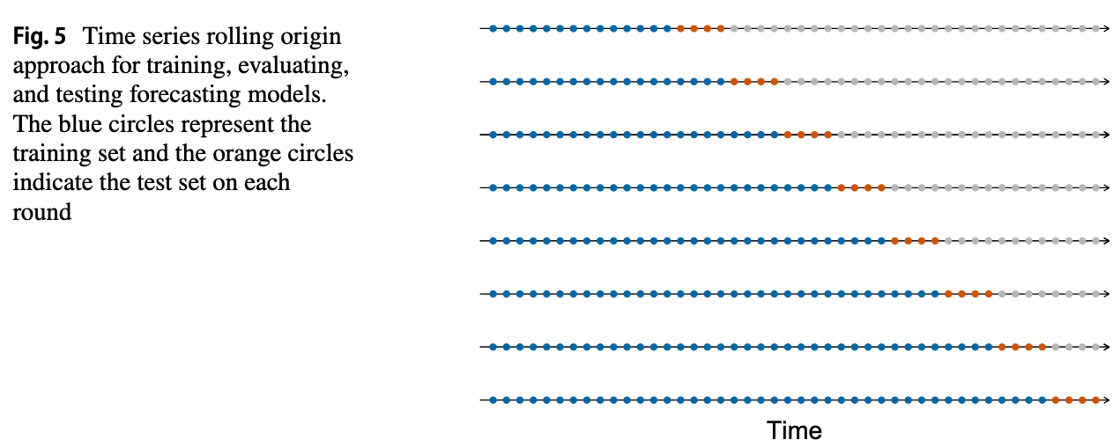

6 - Regularization in Hierarchical Time Series Forecasting with Application to Electricity Smart Meter Data (Souhaib Ben Taieb)

The MinT-REG Algorithm
The authors developed a new method called MinT-REG. Instead of changing every single forecast in the hierarchy to make them match, their algorithm seeks the sparsest adjustments.
- Sparse Adjustments: Using a technique called Elastic Net regularization, the algorithm identifies which forecasts actually need changing and leaves the others alone.
- Adaptive Shrinkage: It applies different levels of "pressure" (penalties) to different levels of the hierarchy so that large aggregated forecasts aren't treated the same as small household forecasts.
- Non-Negativity: It ensures that forecasts never drop below zero, which is essential for data like electricity consumption.

7 - End-to-End Learning of Coherent Probabilistic Forecasts for Hierarchical Time Series (Syama Sundar Rangapuram)
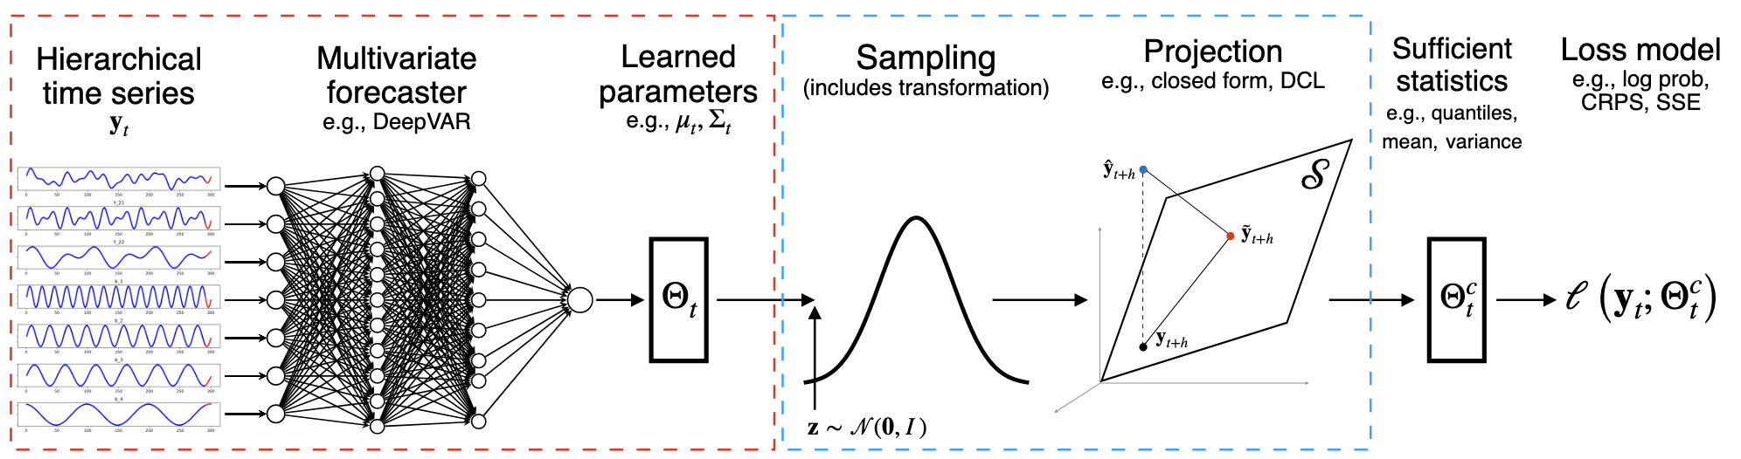

The Proposed Solution: HIER-E2E
The researchers propose HIER-E2E, a single, trainable model that incorporates the reconciliation step directly into the learning process.

Key Model Components
- Multivariate Forecaster (DeepVAR): The model uses a recurrent neural network (RNN) to learn from all time series in the hierarchy simultaneously. This allows the model to capture relationships across the entire history of the data.
- Reparameterization Trick: To make the sampling process differentiable, the model uses the reparameterization trick. This allows the network to be trained using backpropagation even though it involves random sampling.
- Differentiable Projection: The reconciliation step is cast as a convex optimization problem that projects "base" forecasts onto a coherent subspace. In a hierarchical setting, this has a closed-form solution:
$$M = I - A^\top(AA^\top)^{-1}A$$
where $A$ is the matrix representing the aggregation constraints.

3. Advantages of the End-to-End Approach
By combining forecasting and reconciliation into one step, the model offers several benefits over the state-of-the-art:
Feature | Traditional Methods (e.g., MinT, ERM) | HIER-E2E (Proposed)
Learning | Independent for each series | Jointly from all series
Reconciliation | Separate post-processing step | Implicitly part of the model
Forecast Type | Often point-only (except PERMBU) | Fully probabilistic
Constraints | Limited to linear hierarchies | Handles general structural constraints

4. Experimental Results
The authors evaluated the model on five real-world datasets: Labour, Traffic, Tourism, Tourism-L, and Wiki.
- Accuracy: HIER-E2E achieved the best results (lowest Continuous Ranked Probability Score or CRPS) across almost all datasets.
- Uniformity: Unlike some traditional methods that trade off accuracy at top levels for better bottom-level results, HIER-E2E showed consistent performance gains across all aggregation levels.
- Global Learning: The experiments showed that even without the reconciliation step, the global learning nature of the base model (DeepVAR) often outperformed classical hierarchical methods that use univariate models.

8 - Deep LSTM-Based Transfer Learning Approach for Coherent Forecasts in Hierarchical Time Series
Best for coherent probabilistic forecasting.
They developed a Deep Long Short-Term Memory (DLSTM) in an auto-encoder (AE) so DLSTM-AE
two different datasets: 1-the Brazilian electrical power dataset 2- the Australian tourism dataset
Metrics:
MAPE (Mean Absolut Percentage Error),
dRMSE (Root Mean Squared Error of Differences between two consecutive forecasts instead of actual value.),
MSE (Mean Squared Error)

Approach:
They combine some approaches in Deep learning. They are using an Auto Encoder (AE) Architecture contains an encoder that by getting the sequential data as input, try to learn some latent features. And in the decoder part try to generate sequential data from the latent features found in encoder.

For each part of AE they use a LSTM model (Long short-term Memory) that is an RNN model to learn sequent of data.

On the other hand, they are using Transfer learning to reduce the computational cost, first they train the model using just bottom level and then the weights of trained model will be frozen and the model tuned on the upper levels for better forecasts.
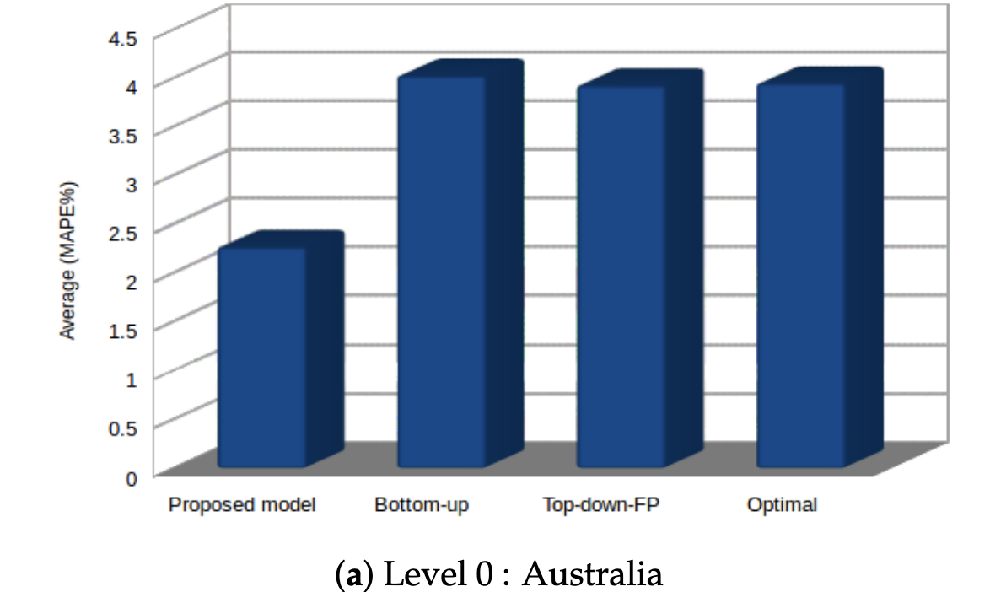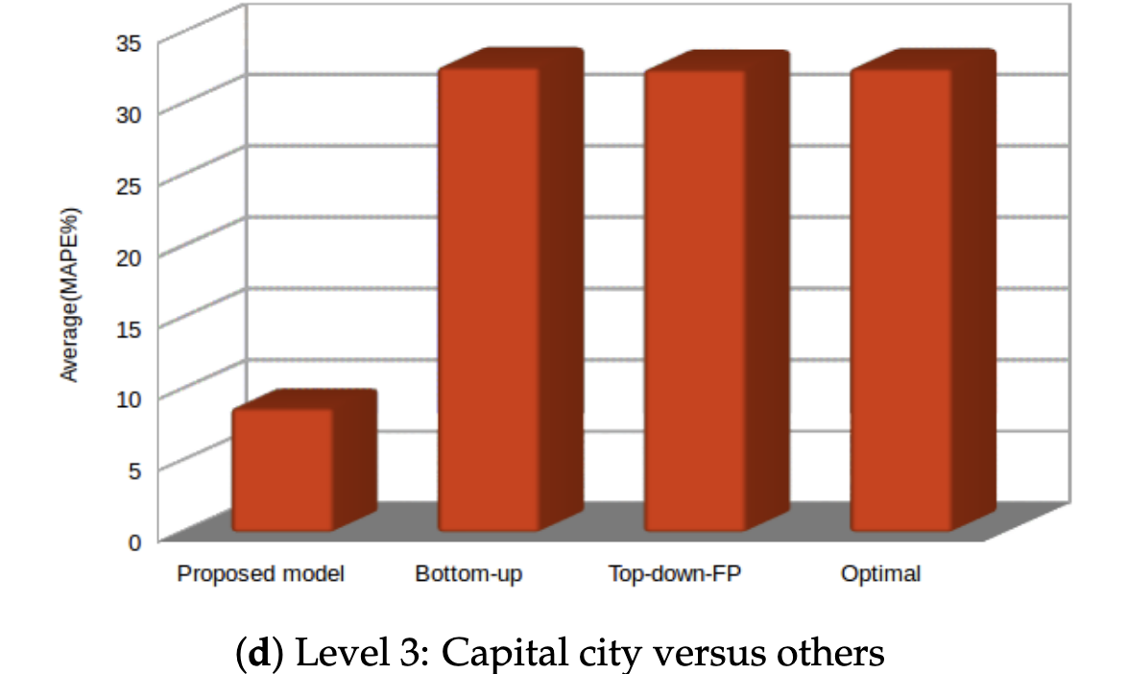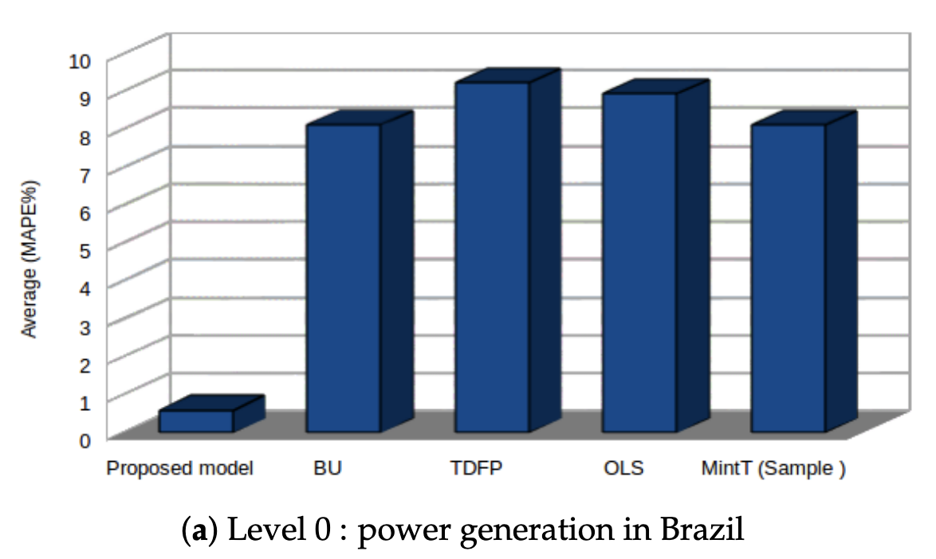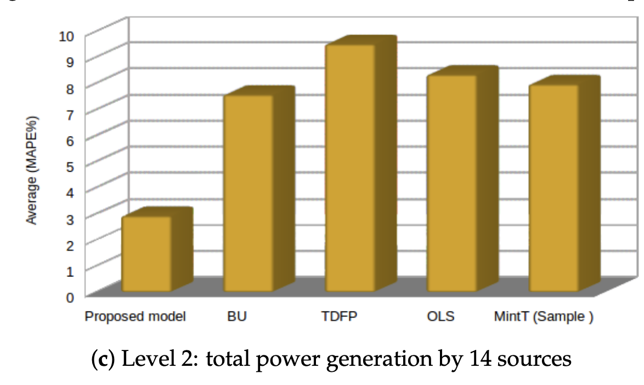

9 - A machine learning approach for forecasting hierarchical time series (Paolo Mancuso)
Best fot point forecasting.
Neural Network Disaggregation (NND)
Limitation: a few years of observations for daily time series are needed
DataSet:
1 - five years Italian grocery store, (3 levels)
2 - electricity demand in Switzerland (2 levels)
3 - Walmart data (M5) (4 levels)

They implemented 2 model. (NND1, NND2)

NND1: The "Direct" Approach
- The Concept: This method jumps directly from the very top of the hierarchy to the very bottom³³.
- How it works: A single model is trained to look at the total aggregate data (Level 0) and immediately predict the most detailed items at the bottom level (Level $K-1$) ⁴.
- Final Step: Once the bottom-level items are predicted, you simply sum them back up to fill in the middle levels of the hierarchy⁵.
- Best for: This strategy was found to be most effective for the bottom-level items themselves, particularly in noisy retail environments like the Italian grocery dataset⁶.

NND2: The "Step-by-Step" (Iterative) Approach
- The Concept: This method follows the natural structure of the hierarchy level by level⁷.
- How it works: Instead of one big jump, separate models are trained for every single branch in the tree⁸⁸⁸. For example, the model first predicts Level 1 from Level 0, then Level 2 from Level 1, and so on⁹.
- Key Difference: It requires training many models in parallel—one for every "parent" series that needs to be broken down¹⁰.
- Best for: This strategy is more flexible and captures the unique patterns of middle levels better¹¹. In the Italian dataset tests, it performed best for middle-level series (like specific brands)¹².

Which one is better?
- NND1 is simpler and faster because it uses fewer models, but it relies heavily on the top-level data to predict the bottom.
- NND2 reduces "bias" because it is more flexible, but it increases "variance" and takes more time to compute because of the high number of models involved¹⁴.

10 – nothing

11 - Hierarchical Probabilistic Forecasting of Electricity Demand with Smart Meter Data (Rob J. Hyndman)
Too long.

12 -

